Java Project



Git install

Download the latest Git for Windows installer from <https://gitforwindows.org/>

Maven Install

Install Java on system

Install Maven on system: Download https://dlcdn.apache.org/maven/maven-3/3.9.0/binaries/apache-maven-3.9.0-bin.tar.gz

1. Visit the Maven download page and download the version of Maven you want to install. The Files section contains the archives of the latest version. Access earlier versions using the archives link in the Previous Releases section.

2. Click on the appropriate link to download the binary zip archive of the latest version of Maven.

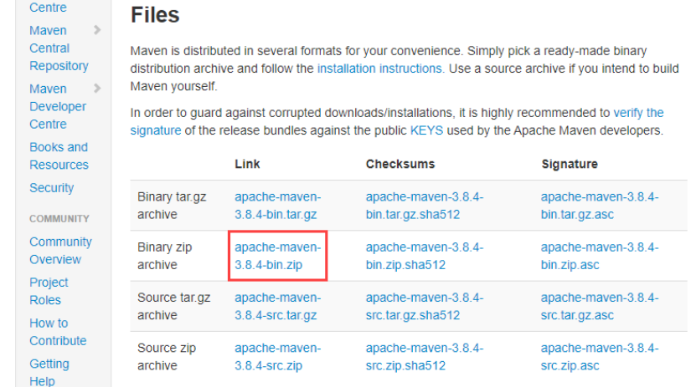

3. Since there is no installation process, extract the Maven archive to a directory of your choice once the download is complete.

Step 2: Add MAVEN_HOME System Variable

1. Open the Start menu and search for environment variables.

2. Click the Edit the system environment variables result.

3. Under the Advanced tab in the System Properties window, click Environment Variables.

4. Click the New button under the System variables section to add a new system environment variable.

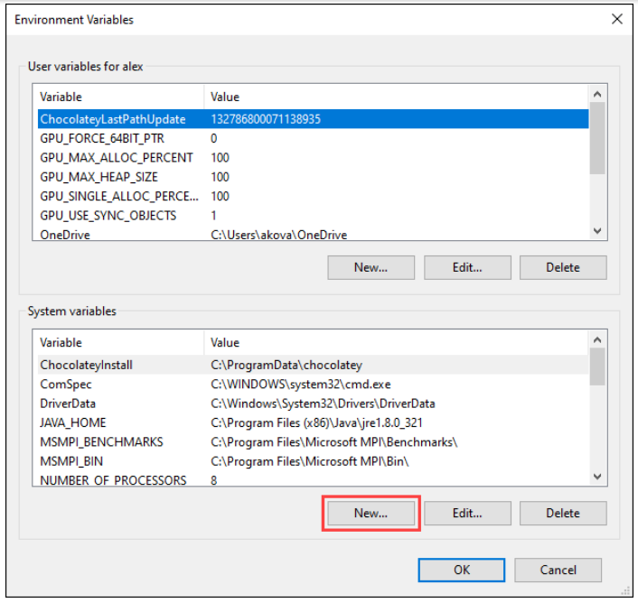

5. Enter MAVEN_HOME as the variable name and the path to the Maven directory as the variable value. Click OK to save the new system variable.

Step 3: Add MAVEN_HOME Directory in PATH Variable

1. Select the Path variable under the System variables section in the Environment Variables window. Click the Edit button to edit the variable.

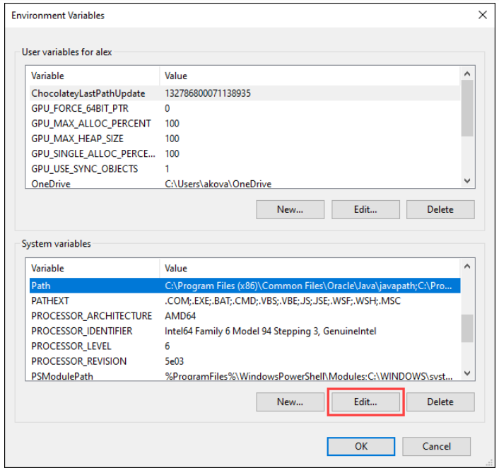

2. Click the New button in the Edit environment variable window.

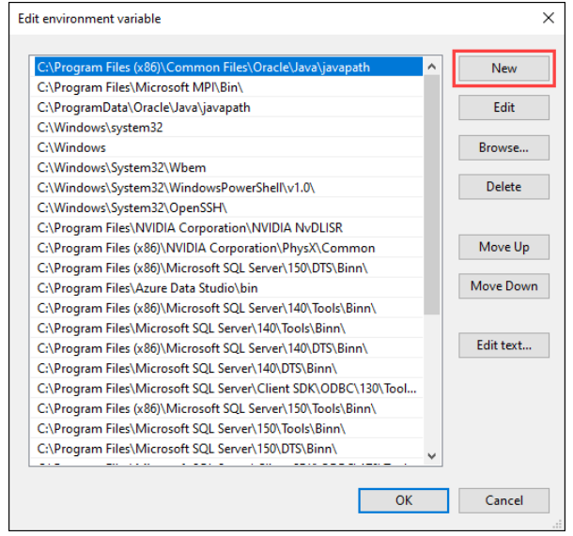

3. Enter %MAVEN_HOME%\bin in the new field. Click OK to save changes to the Path variable.

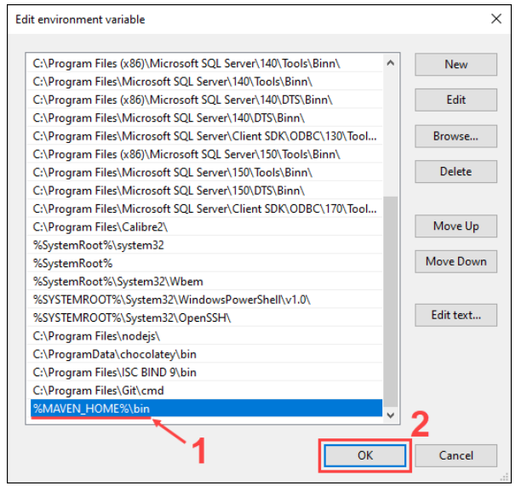

4. Click OK in the Environment Variables window to save the changes to the system variables.

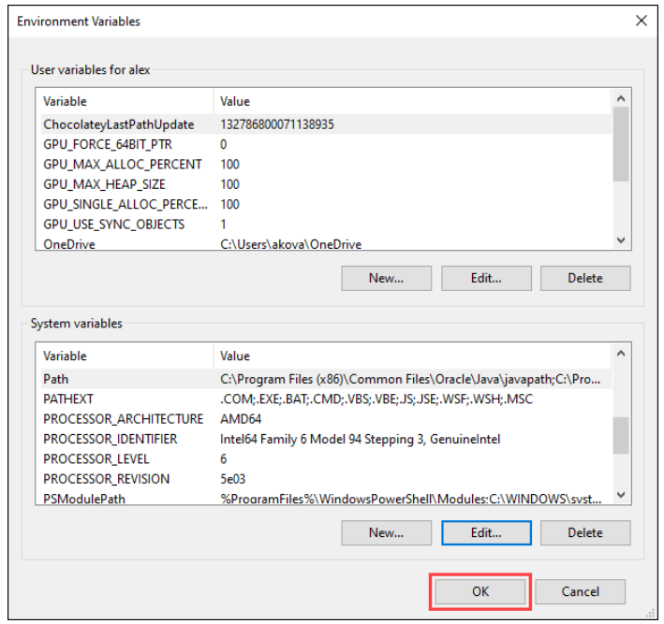

Step 4: Verify Maven Installation

In the command prompt, use the following command to verify the installation by checking the current version of Maven:

mvn -version

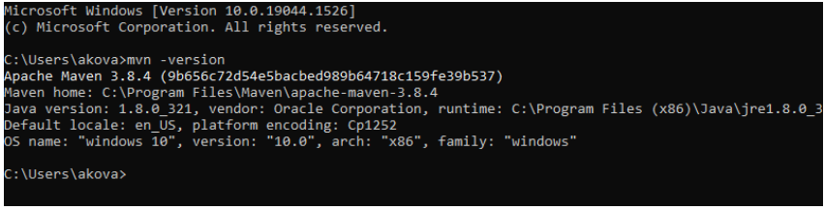

## Install Linux on Windows

1. Press the Windows key and type PowerShell. Select the Run as Administrator option in the right pane:

2. In Windows PowerShell, run the following command to install WSL2:

wsl –install

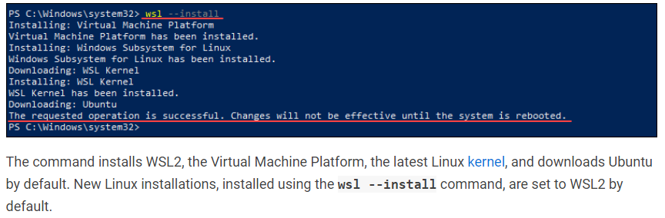

3. Restart the machine for the changes to take effect.

4. After reboot, the Ubuntu instance installation automatically continues, prompting you to choose a username and password.

5. After setting up the username and password, the setup completes, and you can start installing Podman on Ubuntu.

Install Podman

1. Start Powershell as administrator and enter wsl.

2. Follow bellow URL to install podman

https://phoenixnap.com/kb/install-podman-on-ubuntu

Create custom image

1. Create image from dockerfile(Dockerfile is present in :

Hello world code)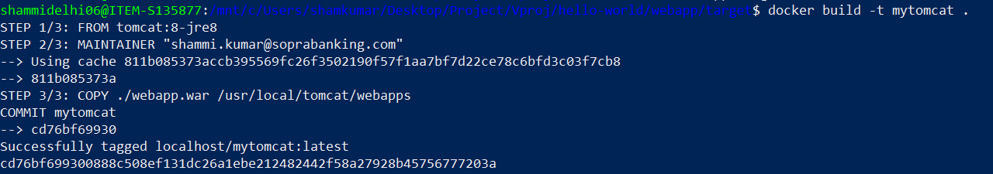

2. Check newly created mytomcat image and run container using that image:

docker images

docker run -d -p 8085:8080 localhost/mytomcat

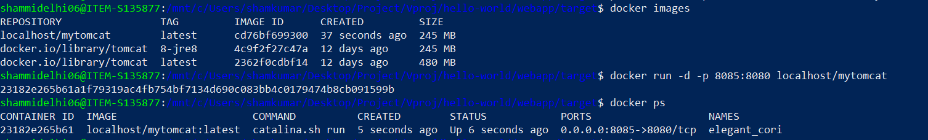

3. Copy all files from /usr/local/tomcat/webapps.dist to /usr/local/tomcat/webapps in container

cd /usr/local/tomcat/webapps.dist

cp -pr * ../webapps/

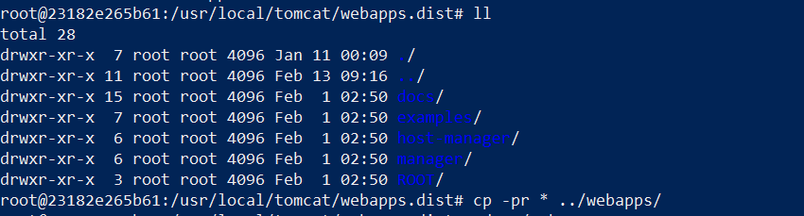

4. Copy context.xml from Hello World project to tomcat container at /usr/local/tomcat/webapps/manager/META-INF/

docker cp context.xml 23182e265b61:/usr/local/tomcat/webapps/manager/META-INF/



5. Copy tomcat-user.xml from Hello World project to tomcat container at

/usr/local/tomcat/conf/

docker cp tomcat-users.xml 23182e265b61:/usr/local/tomcat/conf/



6. Restart tomcat container

docker container restart 23182e265b61

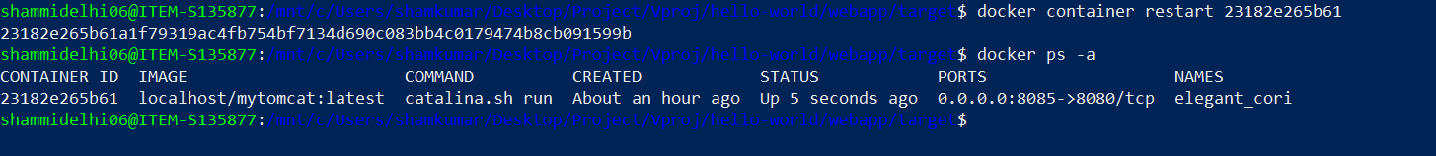

7. Open browser and access url “http://localhost:8085/manager/html”

Username tomcat

Password secret

